Game Graphics in 8-Bit Assembly

This document is a compilation of my notes from the ‘Let's Make EdVenture’ Youtube course by ‘Mission: Ed Possible’. Per the playlist description, this course is a tutorial series for making a Rogue-like in Atari 8-bit 6502 Assembly Language. A big thanks to Ed for creating this incredibly informative playlist!

<https://youtube.com/playlist?list=PL7IgmhqRiwzFrYkkmF2PuxODsAVTSYeZL&si=8MdvZD9ku17IfydM>

Writing a Text Character to the Screen



Writing a String of Text Characters to the Screen

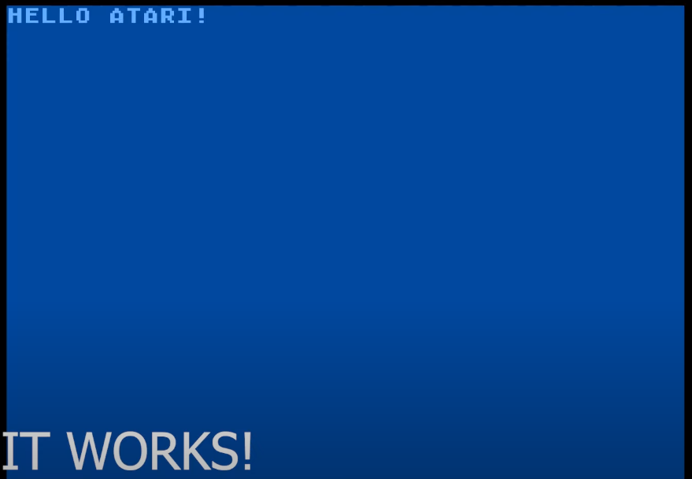

Atari Antic Graphics Modes

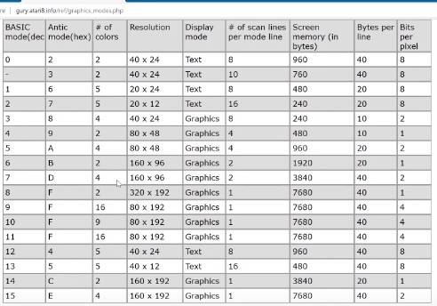

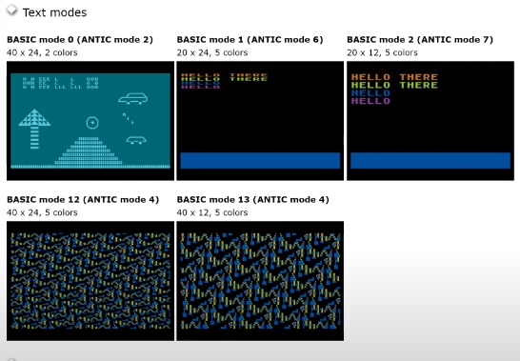

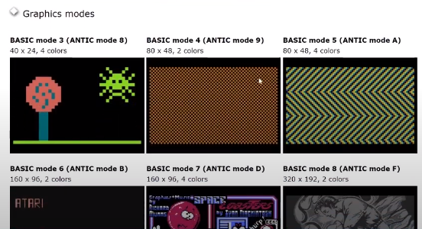

Writing Characters using Antic Mode Graphics

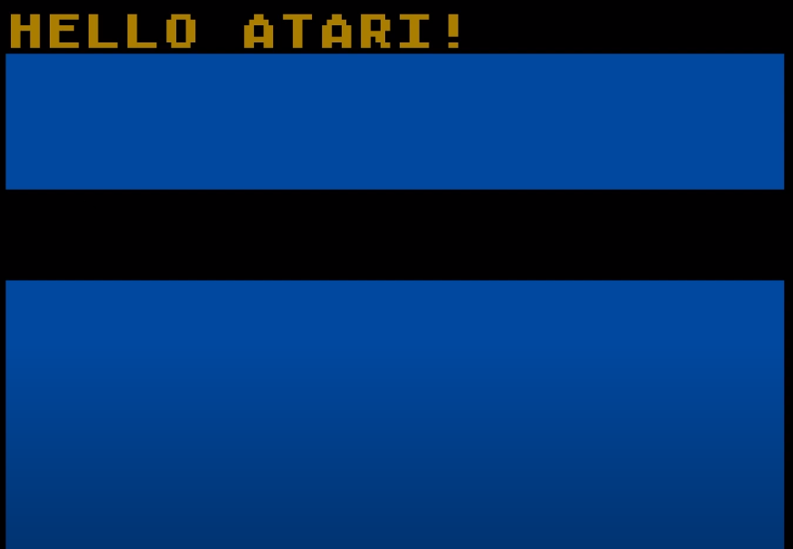

Painting a Single Pixel (Top Right) in tan 8x8 Tile

* Antic 2 for the Top Line, Antic 5 for the Remaing Lines
* Screen is 40 x 20?

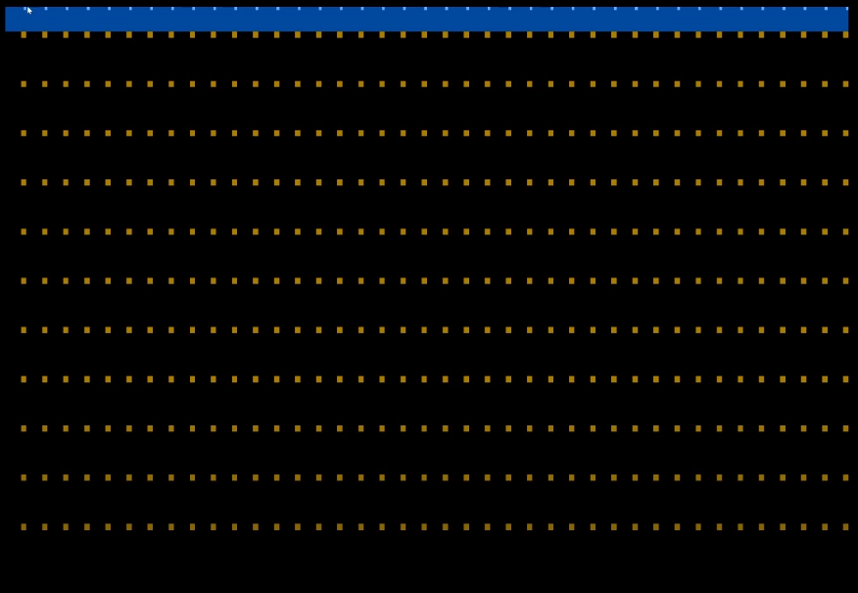

Painting a Slash by Painting Pixels

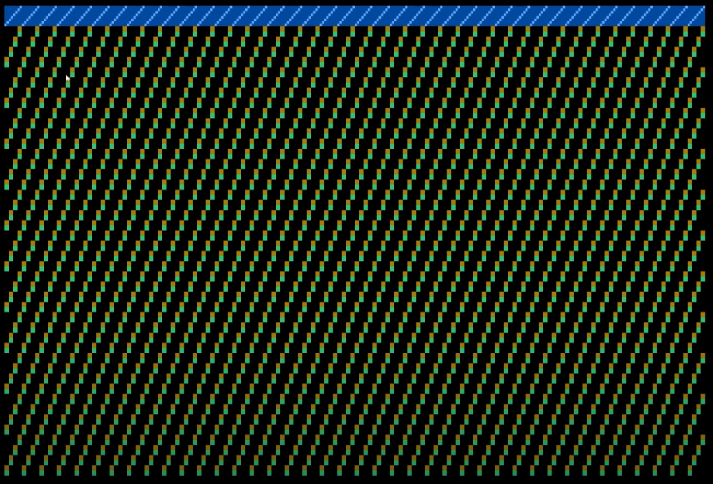

Painting an ‘X’ by Painting Pixels

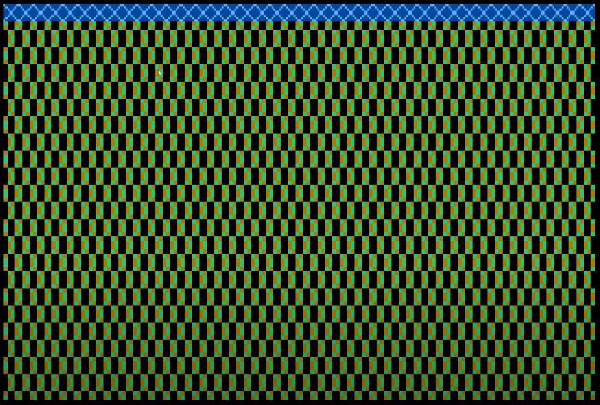

Illustrating Character Width and Demonstrating How We can Create Patters

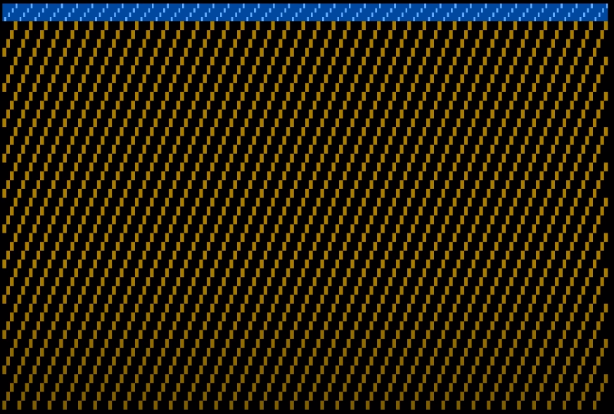

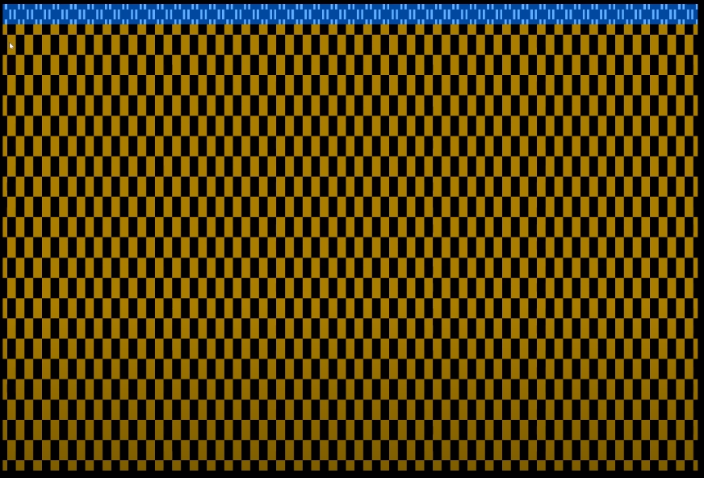

Working towards Creating a Ball

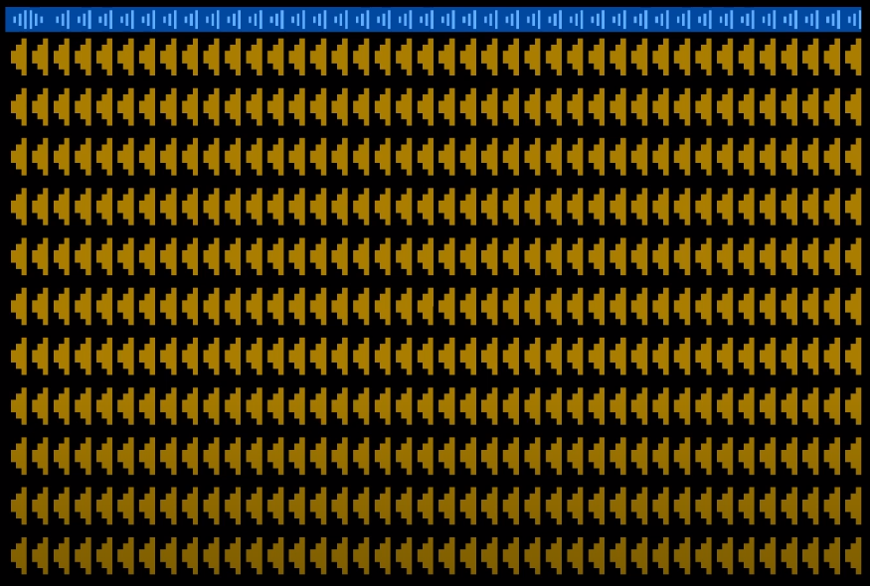

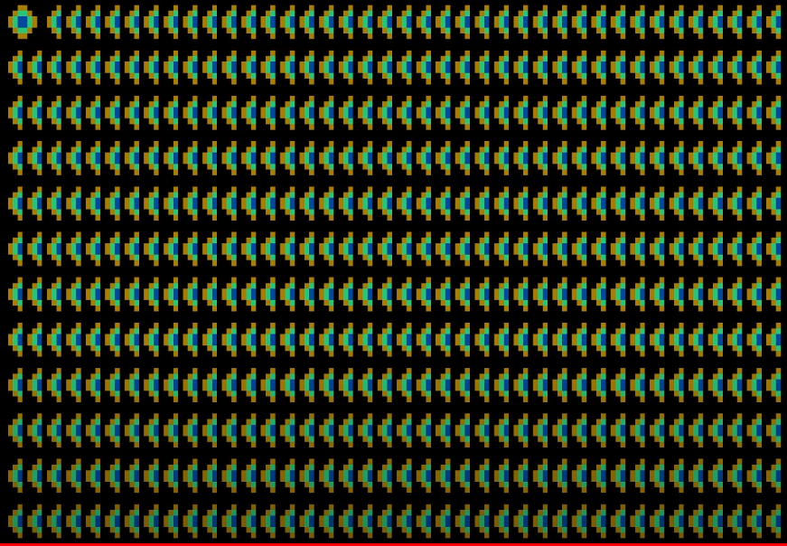

ASCII Character Set

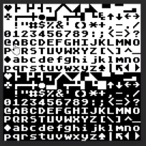

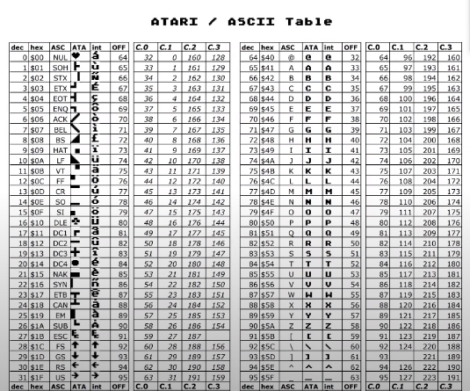

NTSC Palette

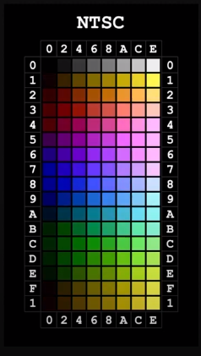

Using Color Tables to Paint Two Separate Colored Balls

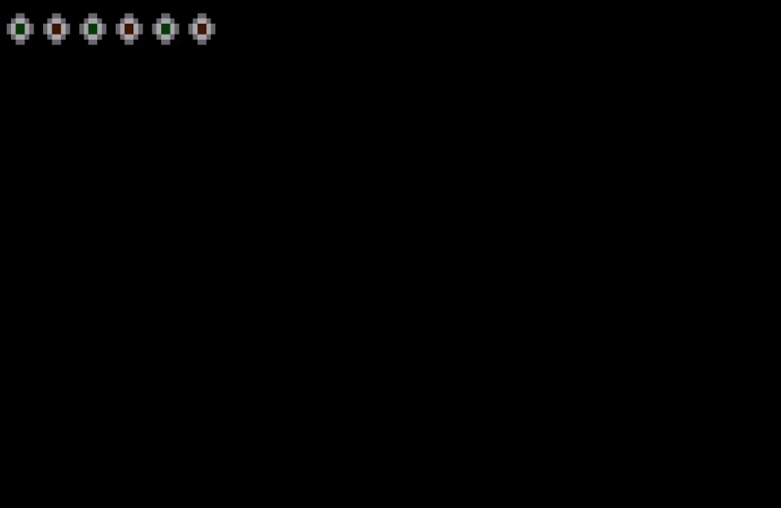

Using PhotoShop to Create Model Graphics

* Single “Wall Tile” Drawn in an 8x8 Grid. The pattern is drawn with the intention on repeating it to create an intricate design

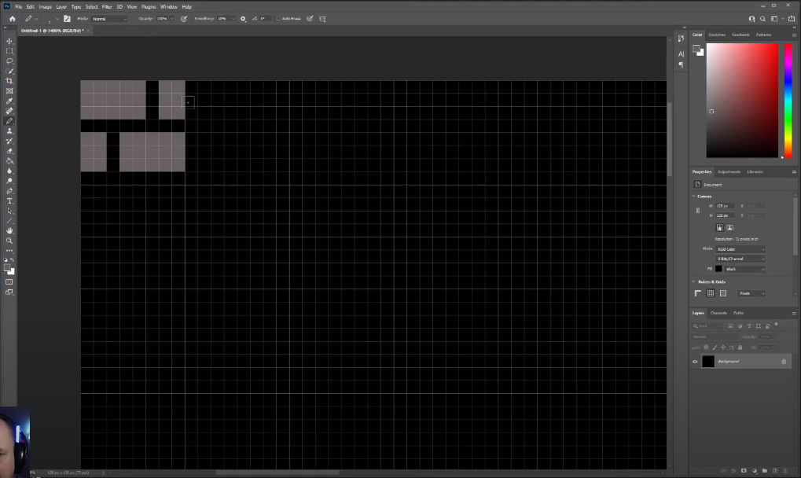

Writing the Code for a Single Tile of the Tile as Drawn in PhotoShop

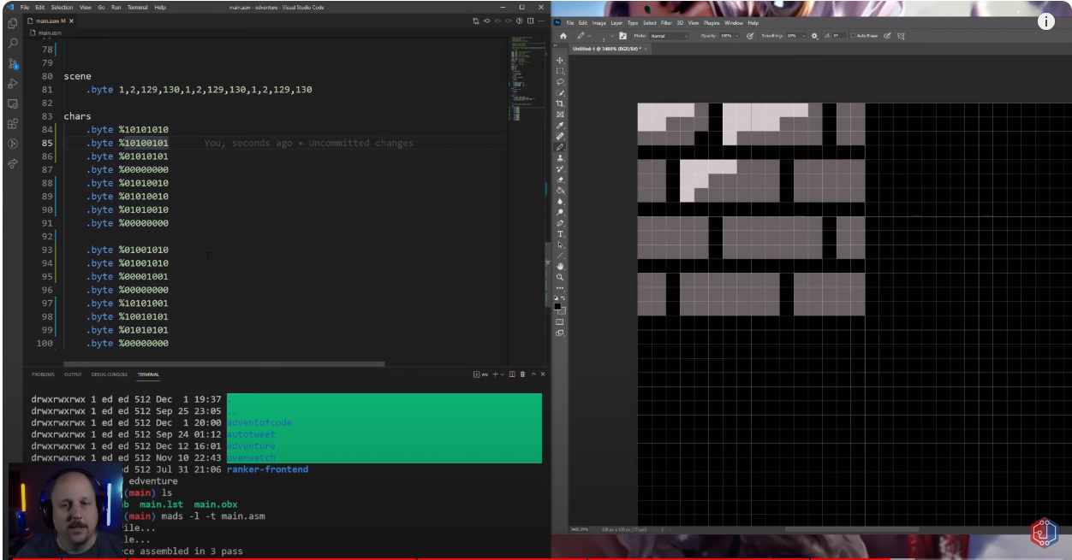

Running the Code

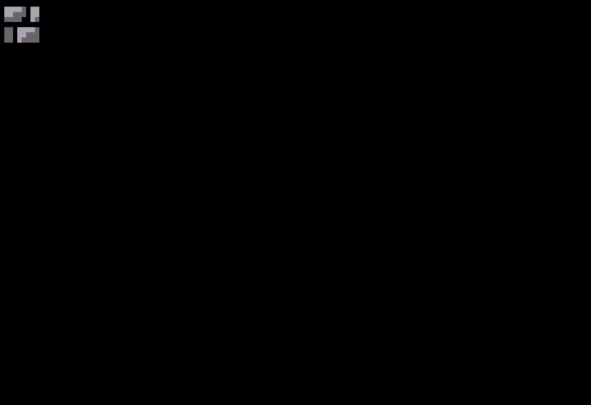

Creating More Model Graphics in PhotoShop

* To create a game map, we create a Wall Tile, a Floor Tile, a Door Tile, and up/down stairs tiles

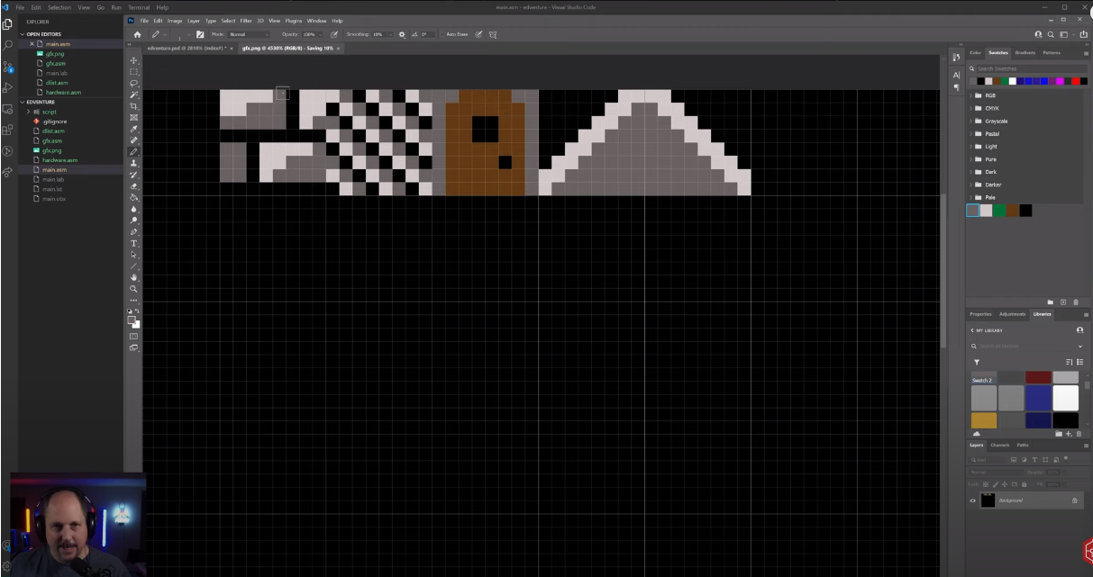

Write Code to Methodically Place the Individual Tiles to Create a Game Map

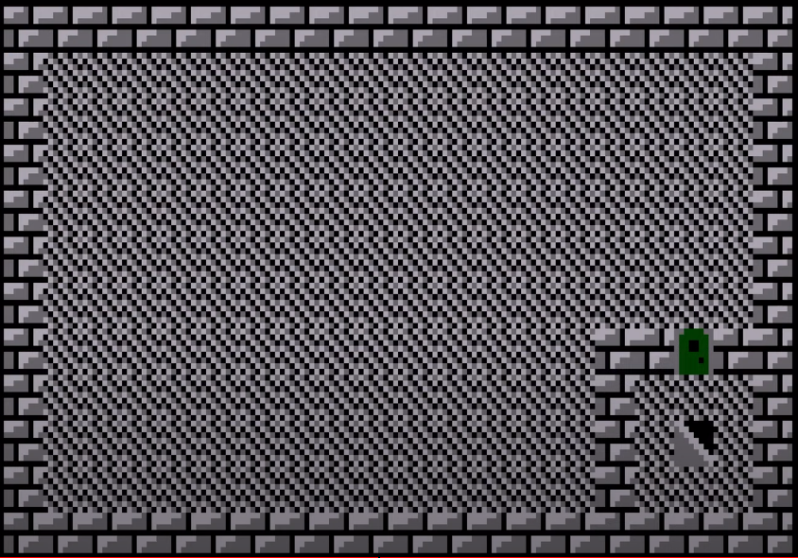

Use PhotoShop to Create a Model Player Character

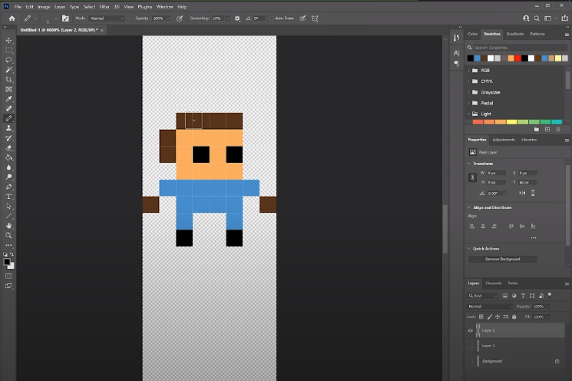

Use Player Missile Graphics (PMG) to Add More Colors and Overlay Player On Top of Map

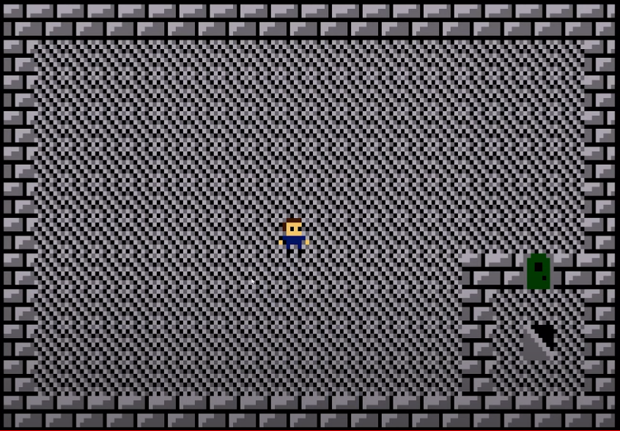

Note that up to this point we’ve been using ‘Characters’ to create graphics. We’re going to change this approach and start using ‘Tiles’.

